**Name: Ammarah Owais**

**Roll No. : 00015418**

**Tempelet#8**

**DAY 3**

**API INTEGRATION REPORT-[SOFA MARKET]**

**My Market Place Name- SOFA MARKET website Templet#8**

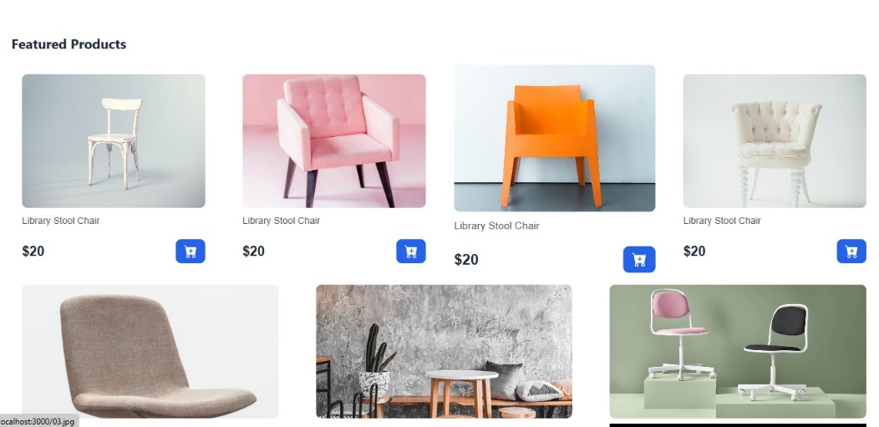

**API Overview:**

API stands for Application Programming Interface. It's a way for applications to communicate with each other by allowing data and functionality to be transferred over a network.

Integrate multiple APIs to fetch data including product information into frontend.

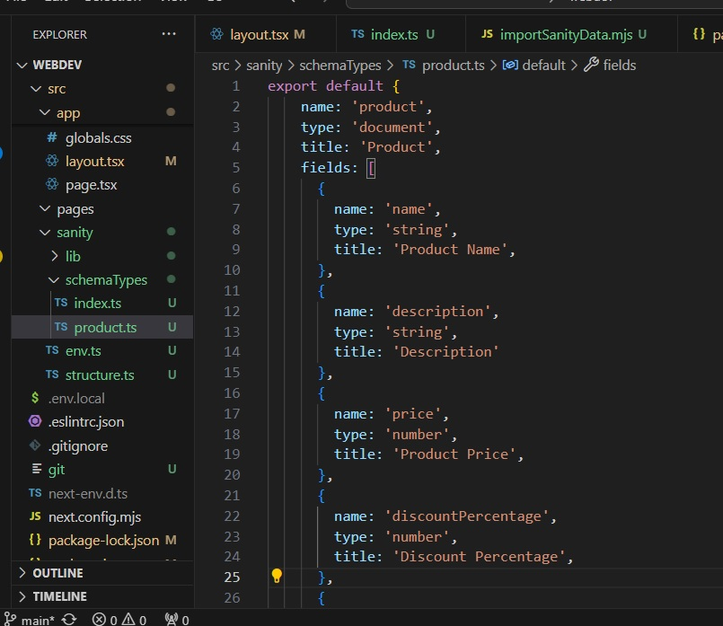

**Migrate data to sanity CMS**

Configured Product schema to ensure they align perfectly with the API data structure.

Employee Tool like .env for secure environment configuration and axios for making API call efficient.

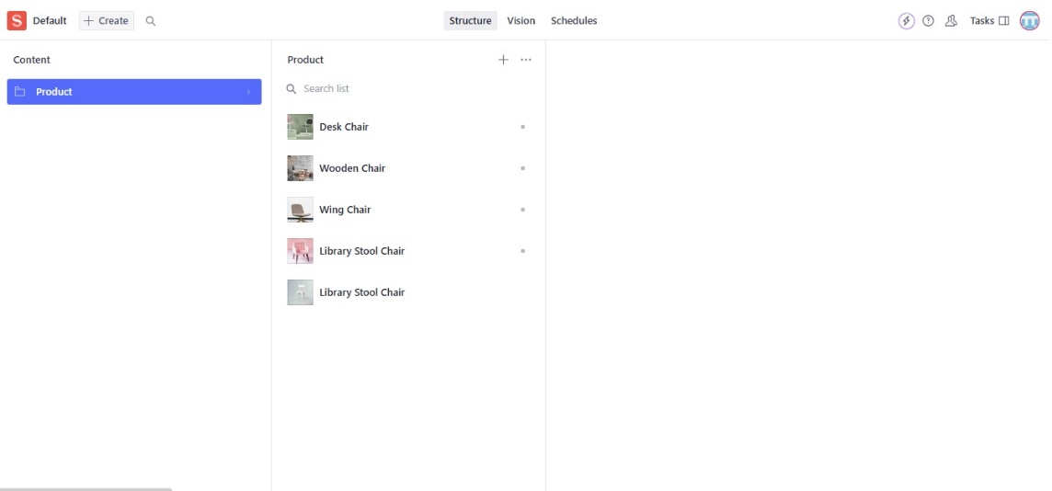

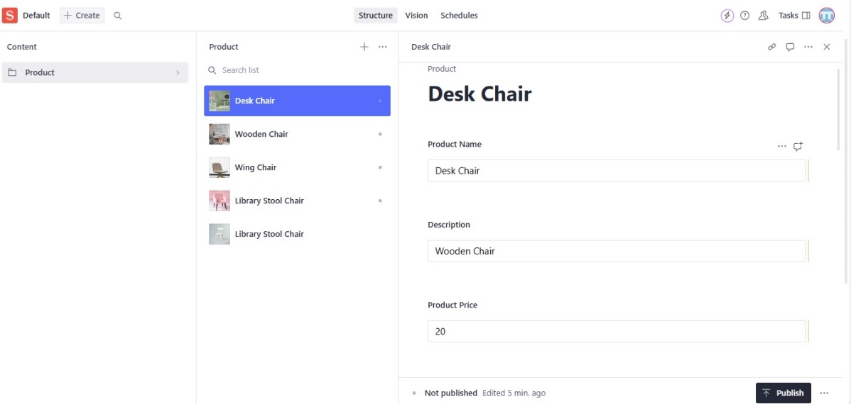

**Self-Validation**

Checklist:

API Understanding:

• ✔

Schema Validation:

• ✔

Data Migration:

• ✔

API Integration in Next.js:

• ✔

Submission Preparation

• ✔